St Paul’s Kogarah Anglican Church

Partnership Course

Introducing St Paul’s Kogarah

Prayer

Bible passage: Matthew 16:13-20

This is a turning point in the Gospel of Matthew. Jesus has been travelling with his disciples and teaching them many things about the Kingdom of Heaven. The disciples have seen what Jesus could do and they’ve heard how he taught as one having authority. As they come to the region of Caesarea Philippi, Jesus asks them plainly, “But you, who do you say I am?”

- Who responds?

- What is his response?

- What’s so significant about his response?

Peter says that Jesus is the Christ. The term Christ means ‘The Anointed One’. In the Old Testament, the kings of Israel were anointed to show that they were chosen by God as the King. While some of the kings in Israel were good, they were all flawed. Throughout the Old Testament, God promises that a King would come who would rule perfectly. He would be the true ‘Christ’ who would rule over God’s kingdom. When Peter confesses that Jesus is the Christ, he’s saying that Jesus is the King God had promised.

More than that, Peter confesses that Jesus is the Son of the Living God. In the Old Testament, the King of Israel was described as a son of God. It carried the idea that the King was acting on behalf of God. That’s most likely what was on Peter’s mind as he uttered the words. However, Jesus is more than just another King of Israel. He is the only Son of God, who had always been with God the Father. He is God the Son, the Second Person of the Trinity. He’s not merely the king of Israel; Jesus is the King of everything.

Jesus makes it clear that Peter hadn’t come to this revelation on his own. Rather it was God the Father who had revealed it to Peter. It is in the light of this God-given revelation that Jesus makes a statement about the Church.

- What does Jesus say about the church in verse 18?

It is by the revelation that God the Father had revealed to Peter, namely, that Jesus is the Christ, the Son of the Living God, that Jesus builds his church. The church is not merely a gathering of people who likes similar things, who share similar ideals. No, the church is built on the understanding that Jesus is the Christ, the Son of the Living God. The church belongs to Jesus Christ; it’s his church. The church, though it appears weak on the outside, cannot be overcome, even by the very gates of hell.The church of Christ is the Church that preaches the gospel of Christ, namely, that Jesus is Lord. It’s this gospel about Jesus Christ that will lead them to heaven. Conversely, the rejection of this gospel which will keep them from entering heaven.

- How is this view of the Church different to how our community sees the Church?

A Reformed, Evangelical, Anglican Church

In terms of what our Church believes, we can be described as a reformed, Evangelical, Anglican Church

Reformed
In between the 1st and the 16th Century, a number of traditions and doctrines were developed in the Roman Catholic Church which many Christians believe were contrary to the teaching of the Bible. In response, many Christians were involved in the Reformation movement. In this movement, Christians affirm that the Bible must remain the authoritative, even over the traditions of the Church. A succinct way to describe what those of the reformation movement believe are the five ‘solas’:

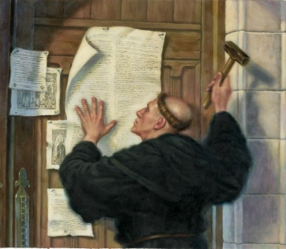
Sola gratia (grace alone)
This Photo by Unknown Author is licensed under CC BY-NC-ND
Sola scriptura (Scripture alone)
Sola fide (Faith alone)
Sola Christus (Christ alone)
Sola Deo Gloria (The Glory of God alone)

Today, thousands of Churches, including St Paul’s Kogarah, identify ourselves as Reformed Churches.

Evangelical
The word Evangelical comes from the Greek word euangelios which means the announcer of good news. An Evangelical, then, is someone who believes in the good news about Jesus as found in the New Testament and he or she is willing to base his or her life on this gospel. In other words, someone who is an Evangelical will allow the gospel to drive his or her life. An Evangelical believes the great truths of the reformation movement. Furthermore, an Evangelical would emphasise the necessity of conversion and regeneration. Evangelicals believe that for someone to be saved, they would need to repent of their sins and by the help of the Holy Spirit, turn back to God.

At St Paul’s, we identify ourselves as Evangelicals whose very lives in this world and the next are dependent completely on the Good News of Jesus Christ.

Anglican
The Anglican Church (also known as the Church of England) established itself in the time of the Reformation. A key person who helped shaped the Anglican Church is the Archbishop Thomas Cranmer. As someone of the reformation tradition, Cranmer formulated a statement of faith for the Church of England called the Thirty-Nine Articles. Cranmer also edited the Book of Common Prayer which contained words used for Sunday services, special services, prayers for Pastoral care, Bible reading and later, the Thirty-Nine Articles.

The Sydney Anglican Diocese had always had an evangelical emphasis. Philip Jensen, the former dean of Sydney, puts it like this, “We are heirs of the Protestant Reformation, seen in our Anglican prayer book and 39 articles of belief. We are heirs of the Evangelical Movement – preaching personal conversion through the regenerating work of the Spirit. We believe and preach this way, using the gifts (charismatic) of God to build the universal (catholic) church with the correct (orthodox) gospel of our Lord Jesus Christ contained in the Scriptures.”

There are currently about 85 million Anglicans in the world, among which are a broad range of beliefs. At St Paul’s, as with the majority of Anglican Churches in the Sydney diocese, we identify ourselves as Reformed, Evangelical Anglicans.

- Why is it important for the Church to be clear about it believes?

Multi-lingual, intergenerational Church

As a reformed, Evangelical Anglican Church, we are keen to share the Good News of Jesus Christ to those around us.

According to the most recent National Church Life Survey, 65% of people living in our area speak a language other than English at home. Around 1 in 10 in our area speaks Mandarin, another 1 in 10 speak one of the Indo-Aryan languages (eg Hindi, Urdu, Bengali) and one in 20 speak Cantonese.

While we want to reach everyone from every language group, we currently have our services in both English and Mandarin. We also have a number of fluent Cantonese speakers. Together, we hope to reach at the multi-lingual community of Kogarah.

As well as reaching people from different nationalities, we want to reach people from different age-groups. The Bible have many lessons on the elder teaching the younger ones how to live according to God’s way. At St Paul’s, we want to encourage this by having multiple opportunities for those who are older to teach those who are younger. Currently, we cater to three specific age groups on Sunday mornings:

KOG Infants: For children from two to five years old
KOG Junior: For children from kindergarten to year four.
KOG Youth: For youth from year five and above.

We also have an intergenerational service called “Generations”. In this service, kids, youth and adults from all ages come together to hear from God’s word and praise God together. It’s a wonderful opportunity to see the older and the younger coming together as one in the Lord Jesus Christ!

- What nationalities have you seen walking around in Kogarah?

- Can you think of a friend who’s not in your age group? How do you relate to them?

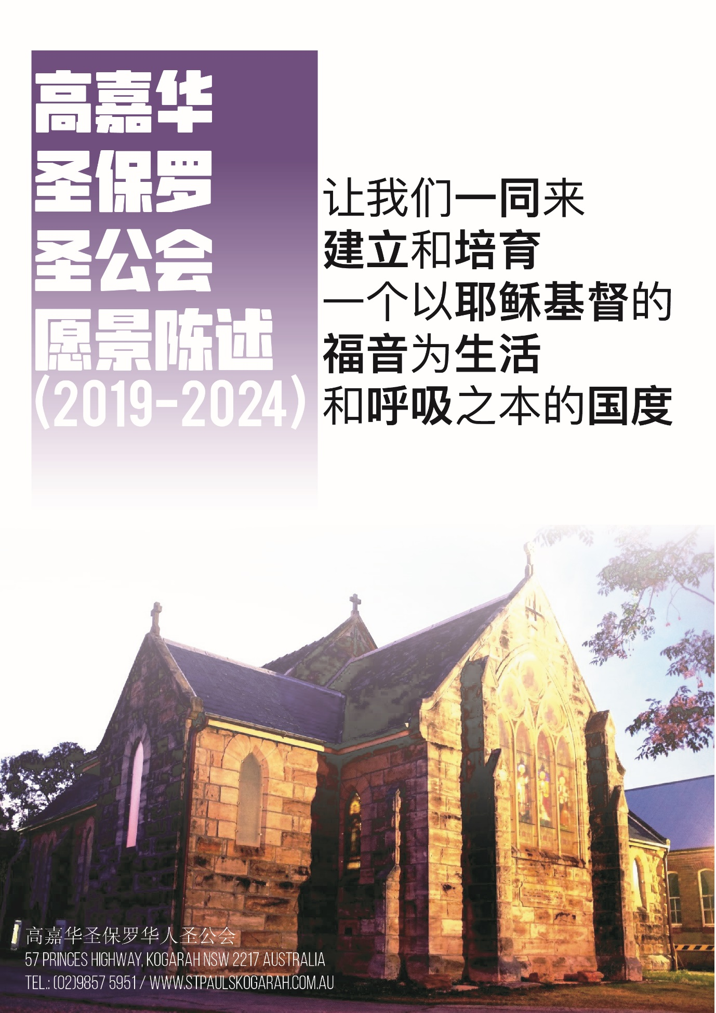

Church with a vision

At St Paul’s, we don’t simply exist for our own sake. We meet together with the following vision:

At St Paul’s, we gather to build and to nurture a kingdom who lives and breathes the gospel of Jesus Christ.

At St Paul’s, we gather together in our 8am, 9:30am Mandarin and the 11:15am Generations service in order to build and nurture God’s people who lives under God’s rule. We want to build them up to become strong Christians who can help others grow. We also want to nurture those who might be young or struggling and help them thrive in a safe environment. All of our building and nurturing are done under the authority of the word of God while trusting that God by His Spirit will transform us to be more like Jesus. As such, we will be a people who will live and breathe the gospel of Jesus Christ. We won’t only talk about the gospel of Jesus Christ, we’ll also live out the gospel of Jesus Christ.

Church tasked with a mission

In order to accomplish our vision under God, we are on a mission to achieve four goals from 2019-2024:

- To reach 150 families in our 150th year
- To produce a campus feasibility masterplan
- To have an exemplary intergenerational ministry
- To become a Chinese discipleship centre in the south

While there are many goals that our Church can aim for, we believe these four goals are what we need to accomplish under God.

- What’s one goal listed here that you can see yourselves getting involved in?

Prayer for Guidance

为神的引导祷告

我们天上慈悲的父，
我们向祢祈祷，
愿祢以福音的真理，指引、洁净和掌管我们的心和身体。
天父，我们的生命只不过像雾气，
转眼消失，
但祢是自有永有的神！
愿祢借着祢的灵，
引导和祝福我们的计划
和手所做的工，
透过我们以信心所献上的服侍，
使多人来荣耀祢的圣名！
靠着我主耶稣基督祈求，阿们！

“Our heavenly Father,
we pray that you will direct, sanctify, and govern our hearts and bodies in the way of the Gospel.
Father, our lives are but a mist but you are from everlasting to everlasting.
By your Spirit, guide and bless what we plan and do,
that through our services offered in faith,
many will give glory to your holy name;
through our Lord and Saviour Jesus Christ. Amen.”

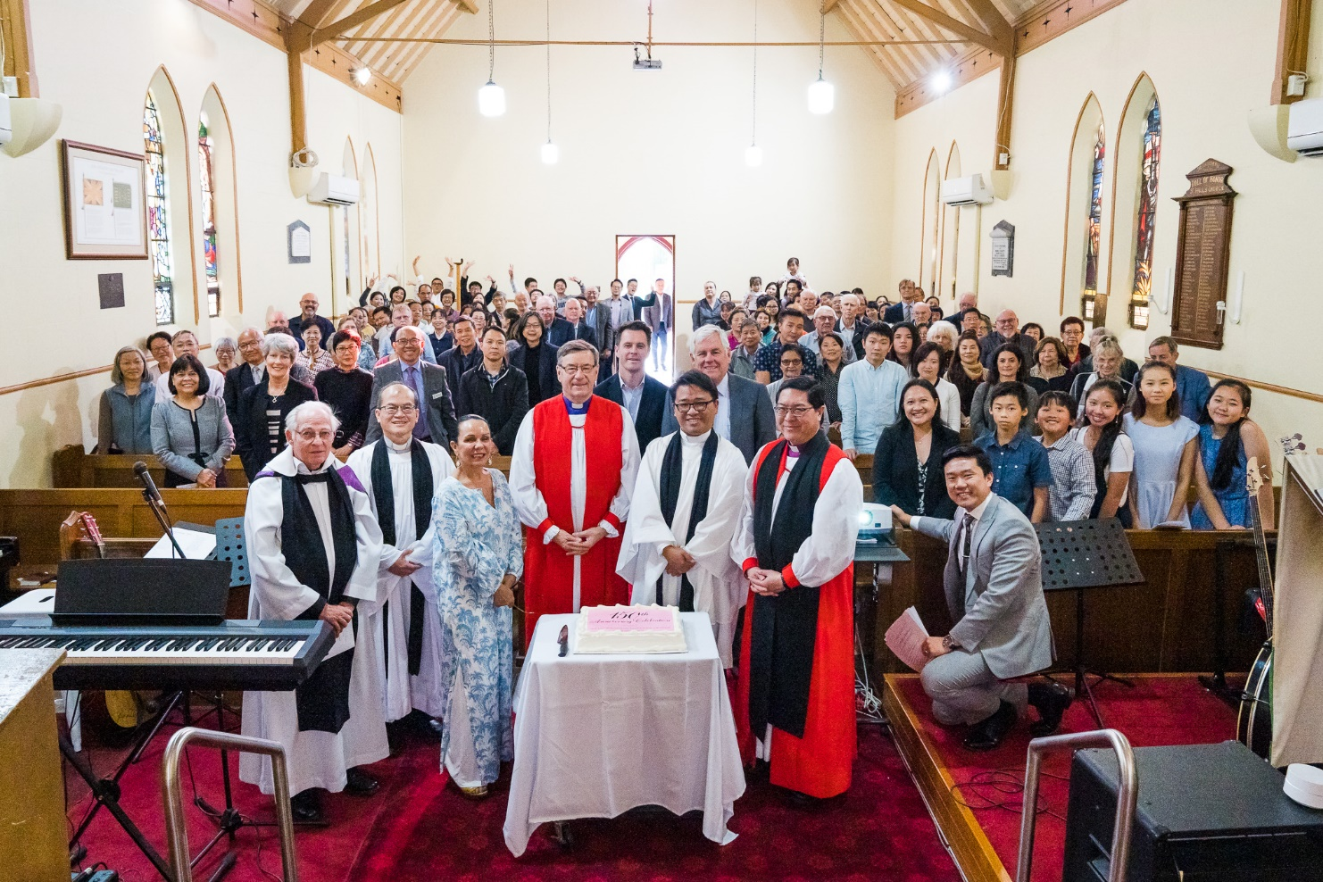

- Partnering at St Paul’s Kogarah

Prayer

Recap: What was the most memorable thing you’ve learnt about Church in the last session?

God’s commitment to us

Bible passage: Ephesians 1:3-14

The Ephesian Church is one of the most mentioned Churches in the New Testament. We first hear about them in Acts 19, when Paul shared the gospel with them and baptised them in the name of the Lord Jesus (Acts 19:1). In time, one of Paul’s companions, Timothy, became a leader of the Church in Ephesus. At that time, the Ephesian Church was facing a number of issues and Paul wrote both 1 Timothy and 2 Timothy to address them. In Revelation, Jesus had a solemn message for the Ephesian Church, who had lost their first love for Jesus. And of course, the Apostle John wrote the Letter of Ephesians to the Christians at Ephesus. The message we’re looking at today is a wonderful passage about how God has committed himself to those who believe in Jesus Christ.

- How many times has the phrase “In him” appeared in these verses?

- Who does the phrase “in him” refer to?

- What does this tell us about how important Jesus is in God’s plan?
This passage is like an overview of what God’s plan for those who belong to Jesus. It’s a plan that looks to the past, the present and into the future.

- When did God choose those who belong to Jesus? (Verse 4)

- Why did God choose them? (verse 5)

- The Bible uses the word ‘redemption’ to describe what God has done for Christians. It’s a word that means paying a great prize to get something back. What did God get back and what was the price that he paid? (verse 7)

- Why did God pay this price?

- What does God have in store for those who are in Christ? (verse 11)

- Whose idea was it for Christians to receive an inheritance from God?

- What does this tell you about God’s commitment to us?

The Bible describes what God’s commitment to us as something that He’s done out of his glorious grace. Grace is the idea that a gift is given out of the sheer generosity of the giver. The person who receives the gift hasn’t earned the gift and doesn’t deserve it. They respond by opening their palms and receiving the gift from the giver. God is the great Giver who has given Christians every blessing in Jesus Christ. We respond to God by accepting it with humble gratitude.

Our Commitment to God

- What does humble gratitude before God look like?

Bible passage: Ephesians 4:1-6

- What does the Bible tell us we ought to do in light of what God has done for us?

God has called Christians to be in Christ. God has not called any person to be a Christian just so that they can live in the same way that they’ve done before. No, being a Christian is a high calling that must be taken seriously. Christians are called to live worthy of the calling they have received.

- How do Christians live out their calling before God? (verses 2-6)

- What would result if Christians live out their calling before God?

- Can this be done without the context of the Church / other believers?

Our Commitment to one another

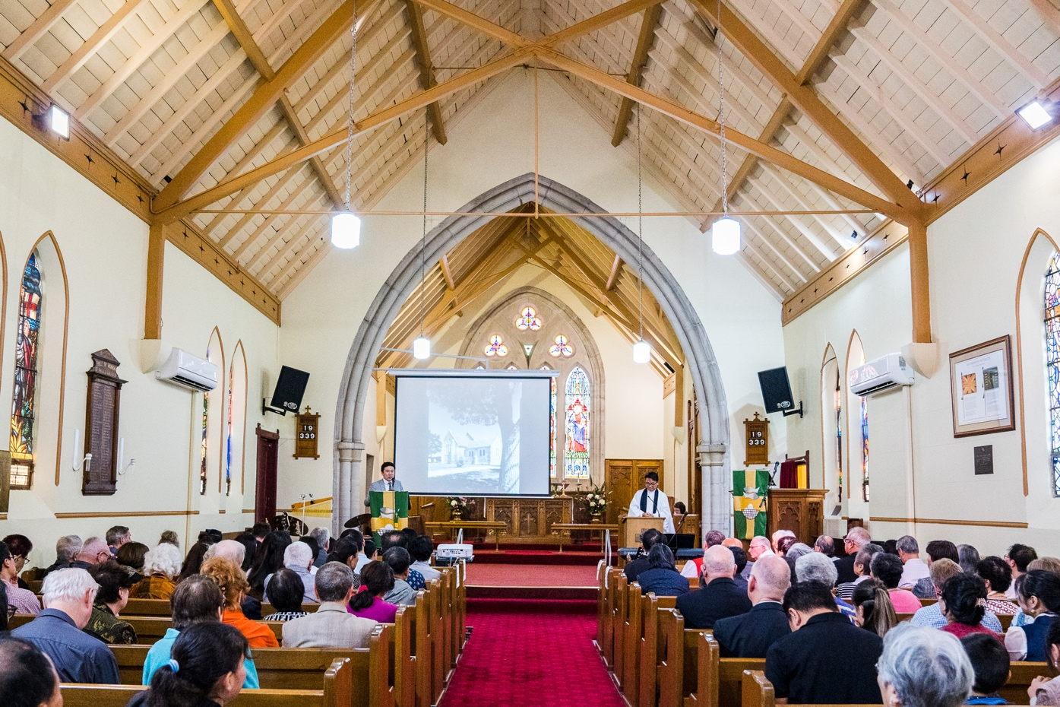
Christianity is a personal faith; it’s the belief that God has been gracious to us and has given those who believe in him his greatest gift, the Lord Jesus Christ. However, it’s not an individualistic faith. The Bible doesn’t speak of individual Christians who live in isolation of one another. The Christian faith is a very communal faith. It’s a faith that shows the unity of the Spirit as believers come together as one body, in the One Spirit, called to the one hope, under one Lord, one faith, one baptism, one God and Father of all.

- What / who unites Christians together?

While it is good to have the unity in the Bible, there will be times when Christians are urged to have unity that are not biblical. It might be a call to unite even though the other group don’t believe in the Bible. It might be a call to unite even though the other group has publicly denied Jesus.

- Can you think of other times when Christians should be weary of call to ‘unite’?

- How should Christians draw the line with regard to unity?

Bible passage: Ephesians 4:7-16
Christians are sinners who had been cleansed of their sins when they put their trust in the Person and the work of Jesus Christ. It’s because he has died on their behalf that their sins are forgiven. In God’s eyes, they are now saints. That’s why the Church is described in the ancient creed as the “one, holy, catholic and apostolic Church”. The Church is a community of sinners who had been transformed into saints.
That doesn’t mean that Christians are perfect. Far from it! Christians will struggle with sin until the day that they die. Even so, Christians believe that God will help them conquer over sin and grow in their trust in Jesus.

- What has God provided to help the saints for their work of ministry?

- What do you notice is the similarity between these gifts whom God has given to the saints?

God’s given the apostles, prophets, evangelists, pastors and teachers pastors to the Church so that they will be equipped for works of ministry and to build up the body of Christ. Notice that it’s not just the pastors and teachers who build up the Body of Christ; it’s the saints, equipped by those who teach them God’s word, to build up the Body of Christ.

- How is the growth of the Church described in verse 16?

As each member of the Body of Christ do their part, building itself up in love, the Body of Christ will grow. It’s a collective effort, driven by the love of God and our love for one another for the growth of the people of God. As saints equipped by the word of God, we are committed to the growth of each other, we’re committed to the growth of the Church.

- How does the Word of God drive you in your commitment to the service of the other saints in the Church?

Our Commitment to you

At St Paul’s Kogarah, we’re committed to equipping the saints who come to our Church for the works of ministry and to build up the Body of Christ. As such, we have teachers and pastors who teach God’s word in the following groups:

KOG Infants (Infants to preschool)
KOG Junior (Kindergarten to year 4)
KOG Youth (Year 5 to year 12)
English Bible Study (Adults – after 8am service)
Chinese Bible Studies (Adults – after 9:30am service)
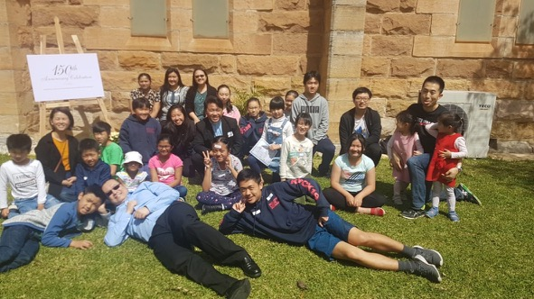
Life of Christ (Sundays after lunch)

We also constantly pray for those among us who are in need at our Church services as well as in our personal prayers at home. If you would like to be prayed for, just let our Minister or your Growth Group leader know!

We are committed to ensure that you are fed with the Word of God and that you are prayed for so that you will grow in the Lord Jesus Christ.

We are also committed to provide for those who have physical needs, whenever possible. We want love one another not only with words, but in action and in truth (1 John 3:18). This is best done in the context of the Growth groups. If you do have special requests for needs, please don’t hesitate to let the Minister of your Growth Group leader know.

Prayer for Guidance

为神的引导祷告

我们天上慈悲的父，
我们向祢祈祷，
愿祢以福音的真理，指引、洁净和掌管我们的心和身体。
天父，我们的生命只不过像雾气，
转眼消失，
但祢是自有永有的神！
愿祢借着祢的灵，
引导和祝福我们的计划
和手所做的工，
透过我们以信心所献上的服侍，
使多人来荣耀祢的圣名！
靠着我主耶稣基督祈求，阿们！

“Our heavenly Father,
we pray that you will direct, sanctify, and govern our hearts and bodies in the way of the Gospel.
Father, our lives are but a mist but you are from everlasting to everlasting.
By your Spirit, guide and bless what we plan and do,
that through our services offered in faith,
many will give glory to your holy name;
through our Lord and Saviour Jesus Christ. Amen.”

- Partnering in God’s mission

Prayer

Recap: What was the most memorable thing you’ve learnt about God’s commitment to us in the last session?

Partnering with God in his mission

Bible passage: Acts 1:1-11

The book of Acts follows the story of the disciples of Jesus after Jesus had risen from the dead. While Acts has generally been known as the Acts of the Apostles, the book can has also been named as the Acts of the Holy Spirit for God the Spirit is seen as the one who leads the disciples as they go on their missions. In other words, the disciples don’t on their mission on their own, rather, they are led by God the Spirit as he takes them on his mission.

- What did Jesus do after he suffered, died on the cross and rose from the grave?

- How long has Jesus appeared to the disciples for?

- What command did Jesus give his disciples?

- What happens after the disciples receive the Holy Spirit?

The Holy Spirit is God, just as God the Father is God and God the Son is God. When a person accepts Jesus Christ as their Lord and Saviour, the Holy Spirit of God comes on the person so that they can believe Jesus and follow him. The Holy Spirit points us to Jesus and gives us the power to believe in and obey Jesus. By the power of the Holy Spirit, we live lives that point other people to Jesus so that they too, can believe in Jesus. By ourselves, it’s impossible to follow Jesus. However, by God’s Spirit, we can persevere and keep trusting in Jesus, all the while pointing people to him.

Bible passage: Acts 2:37-41

- According to Peter, how is a person saved?

- What will happen when you repent and are baptised in the name of Christ?

- Who is this promise for?

- While the promise that comes with the Gospel is for everyone, not everyone had a chance to hear the gospel yet. Who in your circle of influence and friendship do you have whom you think haven’t heard the gospel yet?

b. Our four goals as part of God’s mission
At St Paul’s Kogarah, we believe in the name of Jesus Christ and so we’re called to be partners in God’s mission. In 2018, we looked at our area and we prayed for God’s guidance for how to be partners in his mission to the people of Kogarah. We believe that we gather at Kogarah to build and to nurture a nation which lives and breathes the gospel of Jesus Christ. To arrive at this goal, we have set the following goals for ourselves:

To reach 150 families in our 150th year
There are currently 17000 people in 6000 households living in Kogarah. According to the latest National Church Life Survey, 49% of the people living in our area arrived only five years ago, 56% were born in non-English speaking countries, of which 18.8% have a Chinese ancestry. Out of the 17000 people living in Kogarah, only a small proportion attend the Protestant Churches in the area (we don’t have the data for the Orthodox Church or the Roman Catholic Church). God’s been good to us in our 150th year for we are reaching 191 families on a regular basis with additional 61 families that were reached during this year. Our hope is that we will continue to engage with more people in our community and that we will have up to 150 families joining our Sunday services regularly so that we’ll have more people joining us on God’s mission.

- What would happen if we don’t bring the Good news of Jesus to the people of Kogarah?

To produce a campus feasibility masterplan
We thank God for the faithfulness of the partners in God’s mission here at St Paul’s Kogarah over the past 150 years as they looked after the land and the property that’s been passed on to them. As those presently tasked with looking after the Church and the properties on the land, we want to make sure that the land is well looked after for those who come after us. As such, we want to produce a campus feasibility masterplan to ensure that we are using our property effectively and faithfully.

- What would happen if we don’t manage our property well?

To have an exemplary intergenerational ministry
Kogarah is an educational hub with six schools and one TAFE within walking distance from our Church. On our site, we currently have a Children Centre that operates from Monday to Friday as well as a Mandarin School that operates on Saturday mornings. During school term, we have children and families coming onto our grounds every day of the week! There are many opportunities for us to engage with the families in our suburb!

To ensure that children who come to our Church get to hear the Good News of Jesus Christ, we have a programme ranging from infants to young adults. We want our children and our youth to know that Jesus loves them and the Church loves them as well. That’s why under God, we want to provide an exemplary intergenerational ministry that helps the children see the love of God through the love of the older members and for the older members to be encouraged and to be godly examples for the younger members.

- What would happen if we don’t have any intergenerational ministry?

To become a Chinese discipleship centre in the south
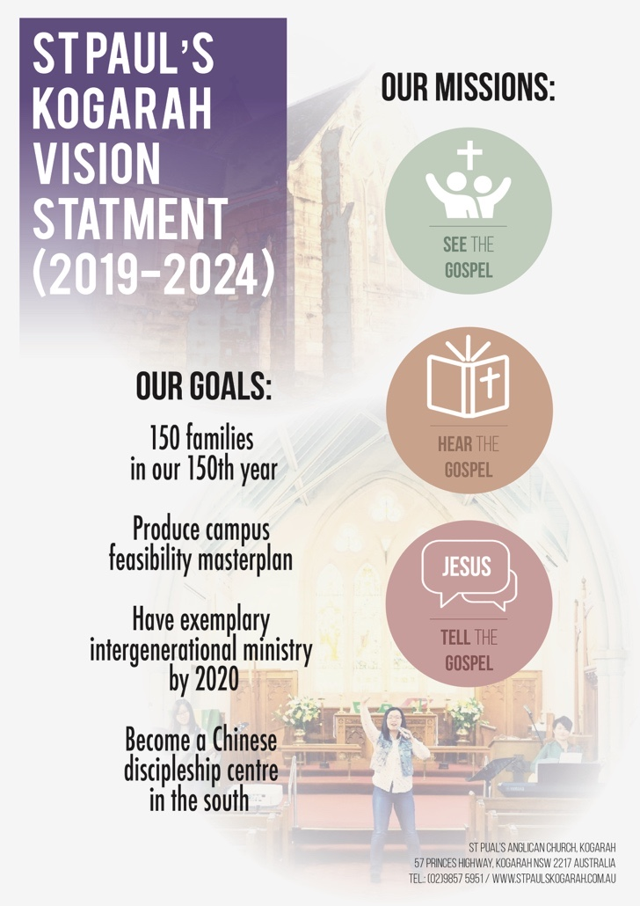
At St Paul’s, as with many Churches from the reformed evangelical tradition, we want to be training centre for the disciples of Jesus Christ. We want to equip the people of God with God’s word so that they can continue to serve God no matter where God might place them. As a Church with a Chinese congregation in the southern region of Sydney, we want to equip Chinese Christians in our area not only to be disciples but to be disciple-makers. As such, we seek to provide trainings, seminars, one-to-one discipleship to train more disciples, both in Chinese and in English. The four areas that wish to train in Chinese are:
- Word Ministry (teaching the Bible in Bible studies and in talks)
- Music Ministry (praising God and teaching the Bible through music)
- Evangelistic Ministry (sharing God’s word with people who don’t know him yet)
- Children Ministry (helping teachers teach the children under their care).

- What would happen if we don’t train people in ministry?

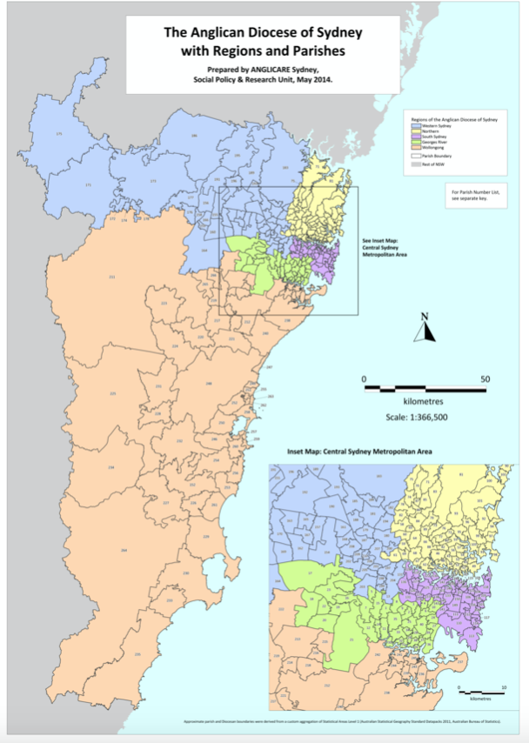
c. Our partnership with other Christian Churches in Sydney
We’re thankful that we’re not alone in our mission. There are thousands of Christians like us around Sydney who are also in God’s mission with us.
As an Anglican Church in the diocese of Sydney, there are 378 registered Churches, located from Hawksbury in the north to Ulladulla to the south, from Botany Bay in the East to Lithgow in the West. Among these Churches are many Christians who are actively involved in God’s mission.
Officially, we’re in the Georges River Region of the diocese and we engage with other Churches in this region in God’s mission. In particular, we engage with the Anglican Churches in our Mission Cluster (St Geroge North, Park Road, Blakehurst, Hurstville, San Souci, Rockdale / Brighton Le Sands) to see how we can pray and support each other as we engage in God’s mission.
As well as Anglican Churches, we often engage with Churches from other denominations, particularly those in the Kogarah area, to see how we can help each other with bringing God’s message to the people in our area.

- What are some ways you can think of for us to interact with other Churches to be involved in God’s mission?

d. Our partnership with other Christians from around the world

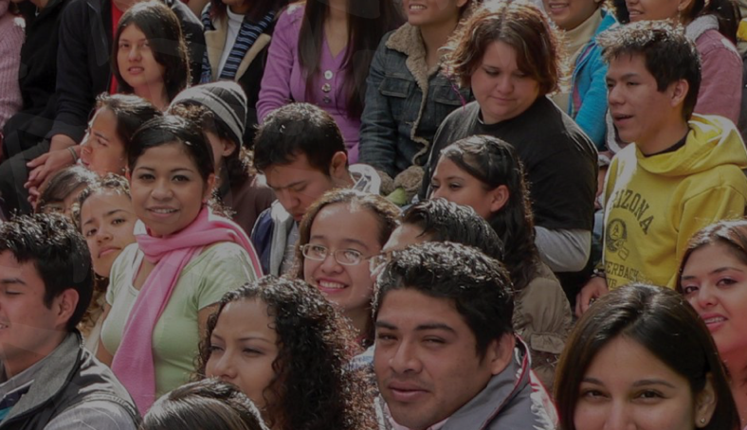
Even if we can reach everyone in Kogarah and even Sydney with the good news of Jesus, there are still thousands upon thousands more who still need to hear it. Currently, there are 3.14 billion people in the world who are classified as Unreached people groups. These are people who less than 2% Evangelical Christians among them. This group make up 42.2% of world population
That’s why at St Paul’s we want to support missionaries both in prayer and in financial support so that they can continue to bring the gospel to those who haven’t heard the good news yet.
At St Paul’s in 2020, we’ll be spending 10% of our budget on a missionary fund. By faith, we want to give this money for mission and for God to use this to use this to bring someone from the dominion of darkness to the Kingdom of God’s Son.
As well as supporting missionaries, we hope that one day God will send people from among our Church to be missionaries, to bring the gospel to a people who have not yet heard of the love of Jesus yet.

- What would happen if we stop sending missionaries to the unreached people groups?

As Jesus himself had said, the harvest is plentiful, but the labourers are few (Matthew 9:37). He asks us to pray that the Lord of the harvest will send more workers into his field. That’s what we’re praying for here at St Paul’s.

Would you join us as we pray to God for more workers? Would you join us as we work with God together on his mission?

Prayer for Guidance

为神的引导祷告

我们天上慈悲的父，
我们向祢祈祷，
愿祢以福音的真理，指引、洁净和掌管我们的心和身体。
天父，我们的生命只不过像雾气，
转眼消失，
但祢是自有永有的神！
愿祢借着祢的灵，
引导和祝福我们的计划
和手所做的工，
透过我们以信心所献上的服侍，
使多人来荣耀祢的圣名！
靠着我主耶稣基督祈求，阿们！

“Our heavenly Father,
we pray that you will direct, sanctify, and govern our hearts and bodies in the way of the Gospel.
Father, our lives are but a mist but you are from everlasting to everlasting.
By your Spirit, guide and bless what we plan and do,
that through our services offered in faith,
many will give glory to your holy name;
through our Lord and Saviour Jesus Christ. Amen.”

